which locate



locate <dir name>locate <file name>

1.Find Files Using Name in Current Directory

# find . -name data.txt

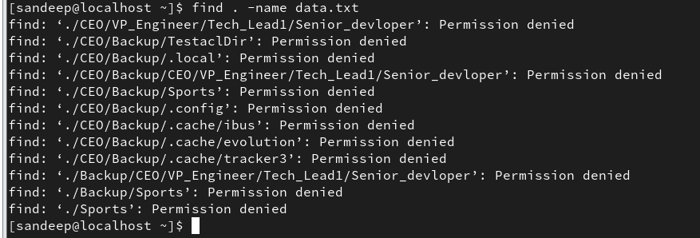

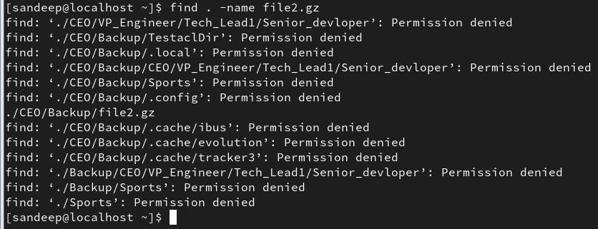

1. Find Files Under Home Directory

# find /home -name test.txt

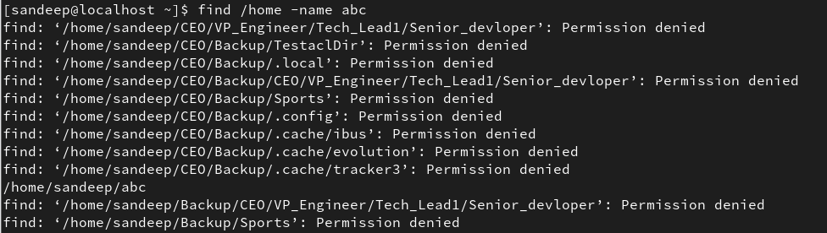

1. Find Files Using Name and Ignoring Case

find /home -iname data.txt

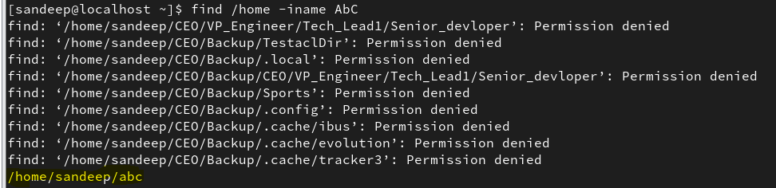

1. Find Directories Using Name

# find / -type d -name Data

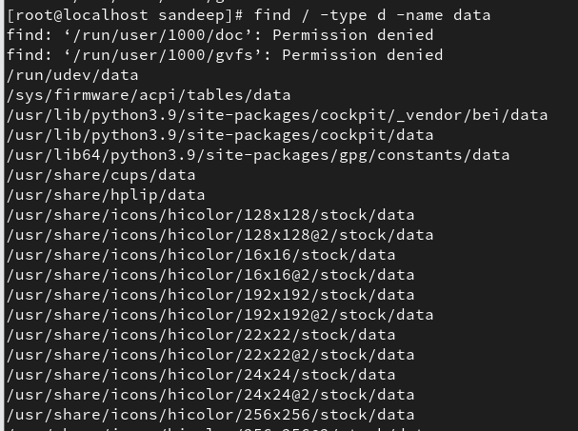

1. Find PHP Files Using Name

# find . -type f -name index.php

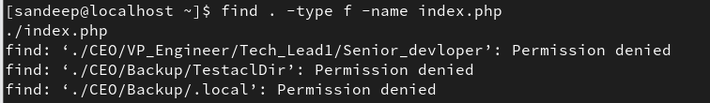

1. Find all PHP Files in the Directory

# find . -type f -name "*.php"

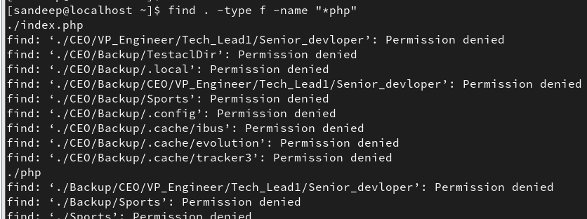

1. Find Files With 777 Permissions

# find . -type f -perm 0777 -print

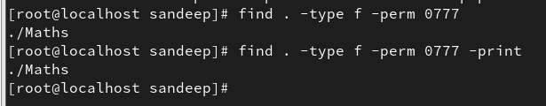

1. Find Files Without 777 Permissions

# find / -type f ! -perm 777

 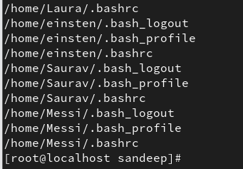

1. Find SGID Files with 644 Permissions

# find / -perm 2644

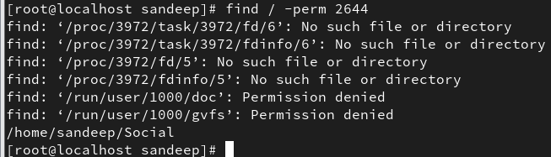

1. Find Sticky Bit Files with 551 Permissions

# find / -perm 1551

1. Find SUID Files

# find / -perm /u=s

1. Find SGID Files

# find / -perm /g=s

1. Find Read-Only Files

# find / -perm /u=r

1. Find Executable Files

# find / -perm /a=x

# find / -perm /a=x

1. Find Files with 777 Permissions and Chmod to 644

# find / -type f -perm 0777 -print -exec chmod 644 {} \;

1. Find Directories with 777 Permissions and Chmod to 755

# find / -type d -perm 777 -print -exec chmod 755 {} \;

1. Find and remove single File

# find . -type f -name "tecmint.txt" -exec rm -f {} \;

1. Find and remove Multiple File

# find . -type f -name "*.txt" -exec rm -f {} \;

OR

# find . -type f -name "*.mp3" -exec rm -f {} \;

1. Find all Empty Files

# find /tmp -type f -empty

1. Find all Empty Directories

# find /tmp -type d -empty

1. File all Hidden Files

# find /tmp -type f -name ".*"

1. Find Single File Based on User

# find / -user root -name tecmint.txt

1. Find all Files Based on User

# find /home -user tecmint

1. Find all Files Based on Group

# find /home -group developer

1. Find Particular Files of User

# find /home -user tecmint -iname "*.txt"

1. Find Last 50 Days Modified Files

# find / -mtime 50

1. Find Last 50 Days Accessed Files

# find / -atime 50

1. Find Last 50-100 Days Modified Files

# find / -mtime +50 –mtime -100

1. Find Changed Files in Last 1 Hour

# find / -cmin -60

1. Find Modified Files in Last 1 Hour

# find / -mmin -60

1. Find Accessed Files in Last 1 Hour

# find / -amin -60

Part V – Find Files and Directories Based on Size

1. Find 50MB Files

# find / -size 50M

1. Find Size between 50MB – 100MB

# find / -size +50M -size -100M

1. Find and Delete 100MB Files

# find / -type f -size +100M -exec rm -f {} \;

1. Find Specific Files and Delete

# find / -type f -name *.mp3 -size +10M -exec rm {} \;

-type

-size

-user

-group

-perm

-delete

-exec

-print

-mtime

-mmin -atime

-amin

-cmin